Hard Conversations: Housing First
What: MDHA, CitySquare, and the Dallas Public Library present a book synopsis of
Housing First: Ending Homelessness, Transforming Systems, and Changing Lives

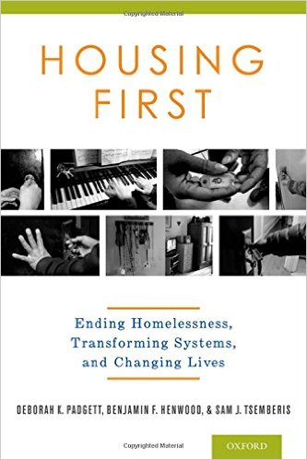

Who: Randy Mayeux, renowned scholar and longtime book reviewer at CitySquare’s Urban Engagement Book Club

When and Where: Monday, September 19, 2016, 12.00-1.30pm, Auditorium (1st Floor) of the J. Erik Jonsson Central Library, 1515 Young St., Dallas, Texas 75201. Follow signs to underground parking on Wood St. Coffee and water provided. Attendees may bring brown-bag lunch.

RSVP to: David Gruber, MDHA, at 469-222-0047 or david.gruber@mdhadallas.org

