The Metro Dallas Homeless Alliance (MDHA)

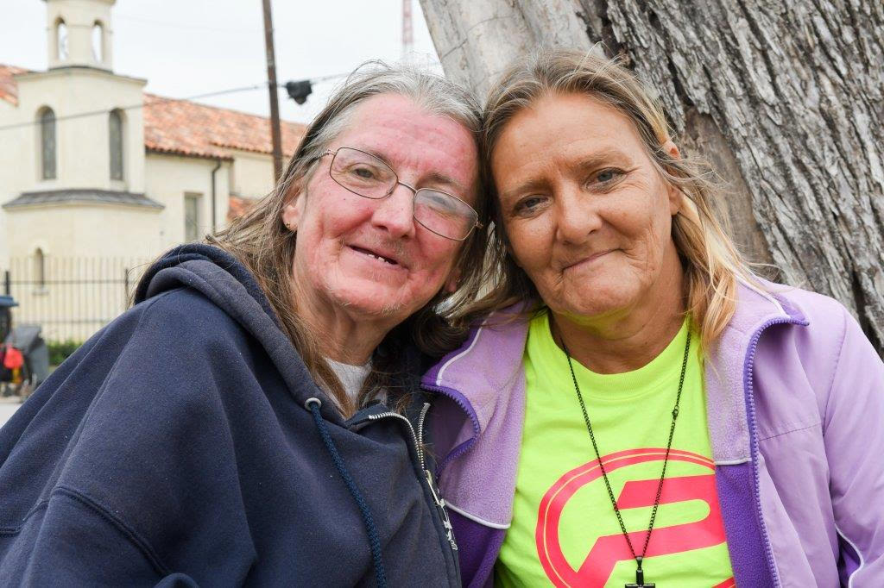
Two of our friends (B.J. Lacasse)

The Metro Dallas Homeless Alliance (MDHA) leads the development of an effective homeless response system that will make the experience of homelessness in Dallas and Collin Counties rare, brief, and non-recurring.

MDHA’s mission rests on the 2009 Homeless Emergency Assistance and Rapid Transition to Housing (HEARTH) Act, and Opening Doors, the national strategic plan to end homelessness, established under the Act. MDHA has five main statutory roles:

- Facilitate $16 million of Federal Continuum of Care funding annually, for homeless services programs;
- Administer the Homeless Management Information System that drives improvement of homeless services programs, currently serving about 9,750 persons;
- Maintain a count of persons experiencing homelessness;
- Maintain an inventory of housing and shelter beds for the homeless and formerly homeless;
- Develop and quarterback an effective unified homeless response system, where all homeless services programs work together to make homelessness rare, brief and nonrecurring.

An effective homeless response system must divert those who can self-resolve and help them do so, place those who cannot self-resolve into appropriate housing, be entirely oriented towards housing as the solution for homelessness, and practice full transparency, as a tool for learning and systems change. In 2015-2016 MDHA made substantial progress in realizing its vision for such a system, and in 2017-2018, it will build on that.

MDHA publishes a quarterly Homeless Response System Community Dashboard, which tracks our community’s progress in moving individuals experiencing homelessness into permanent housing. In 2017-2018, MDHA is focused on improving our community’s performance with each subsequent report.

Interested in learning more about the background of and research behind MDHA’s work? Go to the MDHA in Depth page on our website, and download our playbook.

What Can You Do to Help MDHA End Homelessness?

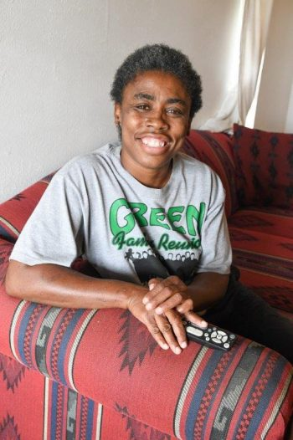
Enjoying her new life (B.J. Lacasse)

- Donate to MDHA. Go to the Give to MDHA page on our website, send a check to 2816 Swiss Ave., Dallas, TX 75204, or contact David Gruber, Development and Communications Director at
469-222-0047 or david.gruber@mdhadallas.org.

- Donate to the MDHA Flex Fund. Check out the MDHA Flex Fund page on our website to learn more about this innovative program, which pays for minor, but impactful expenditures that can help persons end their homelessness.

- Volunteer for the Homeless Count every year. Please mark January 25, 2018 on your calendar now. We will need 1,500 volunteers to get the job done.

- Advocate for what really works. We have clear data on what works. It is important to advocate for what really works, not what we think will work, or what we hope will work. Go to the MDHA in Depth page on our website, and download our playbook, to learn more.

- Advocate for more housing. We have an acute affordable housing crisis. Local governments must take bold and decisive action to create more housing and alleviate this crisis. Make sure your local government officials know how you feel, and create more housing. It is the only proven solution for homelessness.

