2017 Dallas & Collin Counties
Point in Time Homeless Count Results

On January 26, 2017, over 1,300 volunteers took to the streets of Dallas & Collin Counties to count neighbors experiencing homelessness.
3,789
Persons experience homelessness on the streets and in shelters on any given night in Dallas & Collin Counties
Municipality | Unsheltered | Emergency Shelter | Safe Haven | Transitional Housing
Dallas City | 883 | 1748 | 19 | 572
Dallas Co
Grand Prairie | 9 | 11 | 0 | 0
Desoto | 2 | 0 | 0 | 0
Garland | 52 | 0 | 0 | 0
Irving | 33 | 24 | 0 | 27
Collin Co
McKinney | 26 | 0 | 0 | 160
Allen | 0 | 0 | 0 | 10
Anna | 1 | 0 | 0 | 0
Plano | 67 | 78 | 0 | 53
Wylie | 11 | 0 | 0 | 0
Frisco | 3 | 0 | 0 | 0
ALL | 1087 | 1861 | 19 | 822

Sub Population | Unsheltered | Sheltered | Total
Chronically Homeless | 106 | 405 | 511
Chronically Homeless Families | 0 | 31 people in 11 households | 31
Homeless Veterans | 61 | 301 | 362
Unaccompanied Youth and  Parenting Youth Under 18 | 0 | 52 | 52

Chronically Homeless: Homeless at least 1 year or homeless four or more times in the last 3 years where the cumulative time homeless is at least 1 year AND possess a documented disabling condition.
Transitional Housing: Project that is designed to provide housing and appropriate supportive services to homeless persons to facilitate movement to independent living within 24 months – longer if approved
Unsheltered: Place not meant for human habitation (under bridge, outdoor encampment, vehicle, park)
Safe Haven: Supportive housing that serves hard-to-reach homeless persons with severe mental illness who come primarily from the streets and have been unable or unwilling to participate in housing or supportive services.
MDHA leads the development of an effective homeless response system that will make the experience of homelessness in Dallas and Collin Counties
rare, brief and non-recurring.
www.MDHADallas.org ǀ 972-638-5600 ǀ @MDHA2 ǀ MDHADallas

2017 State of the Homeless Address

On Thursday, March 9, 2017, about 350 people joined us at Goodwill Industries of Dallas, for the State of the Homeless Address.
We were honored to hear introductory words from MDHA board member, Dallas County Commissioner, Dr. Theresa Daniel, and Chair of the MDHA board, Executive Director of the Turtle Creek Recovery Center, John Castaneda.
Cindy J. Crain, MDHA President and CEO, shared the results of the 2017 Point-in-Time Homeless Count, and the progress of the Homeless Response System. You can watch the proceedings here: https://youtu.be/8JYhxfxHYOs
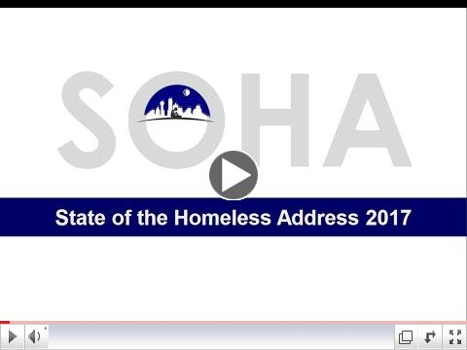
Click here to download Cindy's PowerPoint Presentation
Our MDHA - Just the Basics sheet is a great resource to bring you up to date on the progress of our community's fight to end homelessness, which we are tasked with leading, here in Dallas and Collin Counties. You can read Cindy's most recent Dallas Morning News column here:
The connection between housing the homeless and building roads

MDHA leads the development of an effective homeless response system that will make the experience of homelessness in Dallas and Collin Counties rare, brief and non-recurring.
www.MDHADallas.org ǀ 972-638-5600 ǀ @MDHA2 ǀ MDHADallas

http://www.mdhadallas.org/wp-content/uploads/2017/01/SOHA-2017-Crain-v11.pdf.
http://www.mdhadallas.org/wp-content/uploads/2015/06/MDHA-Double-One-Pager.docx
http://www.dallasnews.com/opinion/commentary/2017/04/03/connection-housing-homeless-building-highways

